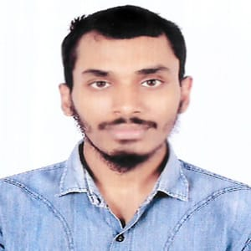**Resume of**

**Arif Islam**

**Rangpur, Bangladesh**

Cell : +8801986082003

E-mail : banbrur1901008@gmail.com

I am a young learner with high ambitions and looking for challenging opportunities where I will have the scope to utilize my communication skill, Adaptability, leadership quality and all the competencies I have, to do something innovative and from where I will be able to enhance my knowledge and experience.

**Educational Qualification**

**01. Bachelor of Arts (BA)**

Name of Institution : Begum Rokeya University, Rangpur

Department : Bangla

Examination year 2023

Result : CGPA 3.46 out of 4.00

**02. Higher Secondary Certificate (HSC)**

Name of Institution : Chandgang College, Dinajpur

Group : Science

Board : Dinajpur

Examination year 2018

Result : GPA 3.42 out of 5

**03. Secondary School Certificate (SSC)**

|  |  |
| --- | --- |
| Name of the school | : Uttar Goshaipur Ideal High School,Dinajpur |
| Group | : Science |
| Board | : Dinajpur |
| Examination Year | 2016 |
| Result | : GPA 3.78 out of 5 |

**Skill**

• Basic Computer Skills include MS Word, MS Excell, Power point. Digital Marketing, Graphics design, Web Development

|  |  |  |  |  |  |  |
| --- | --- | --- | --- | --- | --- | --- |
| **Language Proficiency** | | |  |  | |  |
| Sl. no Language | | | Listening | Understanding | | Speaking |
| 1. Bengali | | | Very Good | Very Good | | Very Good |
| 2. English | | | Better | Better | | Good |
| **Personal Information** | | |  |  | |  |
| Name | : ARIF ISLAM | | |
| Mother’s Name | : Mst. Hashmatun Begum | | |
| Father’s Name | : Md. Jabed Hossain | | |
| Present Address | : Sardarpara ,Rangpur sadar,Rangpur | | |

Begum Rokeya University, Rangpur.

Permanent Address : Village : Boroil, Post : HSTU

|  |  |
| --- | --- |
| District | : Dinajpur |
| Sex | : Male |
| Height | : 5’8” |
| Weight | : 60 |
| Blood Group | : A+ (Positive) |
| Date of Birth | : 27 September 1999 |
| Marital Status | : Single |
| Nationality | : Bangladeshi (by Birth) |

I declared that all the information given in my Resume are true.